Properties of water
  - High heat capacity
    - Absorbs/releases large amounts of heat before changing temperature
  - High heat of vaporization
    - changing from a liquid to a gas requires large amounts of heat
    - Keeps body from overheating
  - Polar solvent properties
    - dissolves ionic substances
    - serves as the body’s major transport medium
  - Reactivity
    - hydrolysis and dehydration synthesis
  - Cushioning
    - resilient cushion around certain body organs

pH Scale (0-14)
- Acids (0-6.9) vs. bases (7.1-14)
- Neutral (7) ex: Pure water (distilled water)
  - equal H⁺ and OH– concentrations
- Water breaks up (dissociates) equal number of hydrogen (H) and hydroxide (OH) ions
- Acid solutions
  - release H
  - ex: Tomato juice, coffee, vinegar
  - Sour taste
- Basic solutions (also called Alkaline)
  - release OH and gain H
  - ex: Antacids (MOM, Rolaids, baking soda, etc.), ammonia, soap, cleaners, detergents
  - Bitter taste, slippery feel when wet
- Buffer
Systems that resist abrupt and large swings in the pH of body fluids

Compounds
- Organic compounds
  - Contain carbon, are covalently bonded, and are often large
C₆H₁₂O₆
- Inorganic compounds
  - Do not contain carbon
  - H₂O
  - NaCl

Carbon-Based Molecules

- Be able to identify the macromolecule illustrated in each diagram below. Use the list to match each one.

- Monosaccharide
- Nucleotide
- Polysaccharide
- Glycerol and 3 fatty acids (Triglyceride)
- Protein (functional)

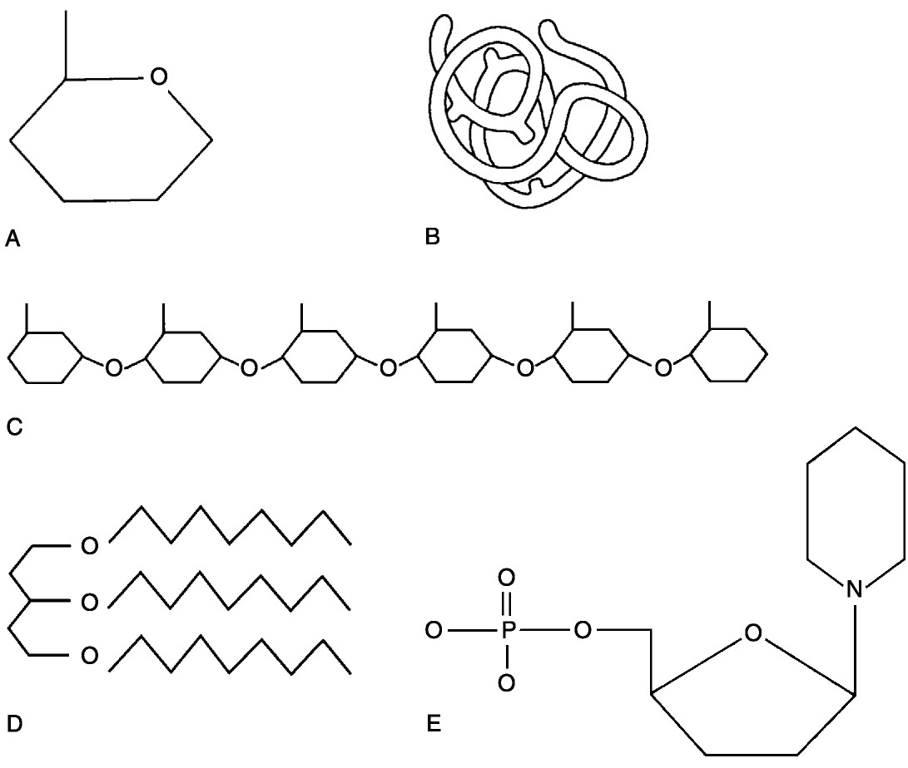

- Be able to identify the name and function of the molecular structure illustrated in the diagram below.

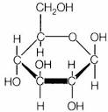

- Be able to identify the name and function of the molecular structure illustrated in the diagram below.

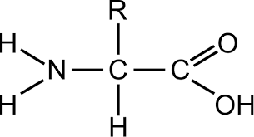

- Be able to identify the name and function of the molecular structure illustrated in the diagram below.

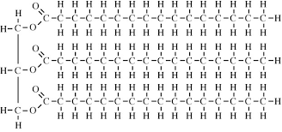

- Be able to identify the labeled structures in the helical structure of deoxyribonucleic acid (DNA):

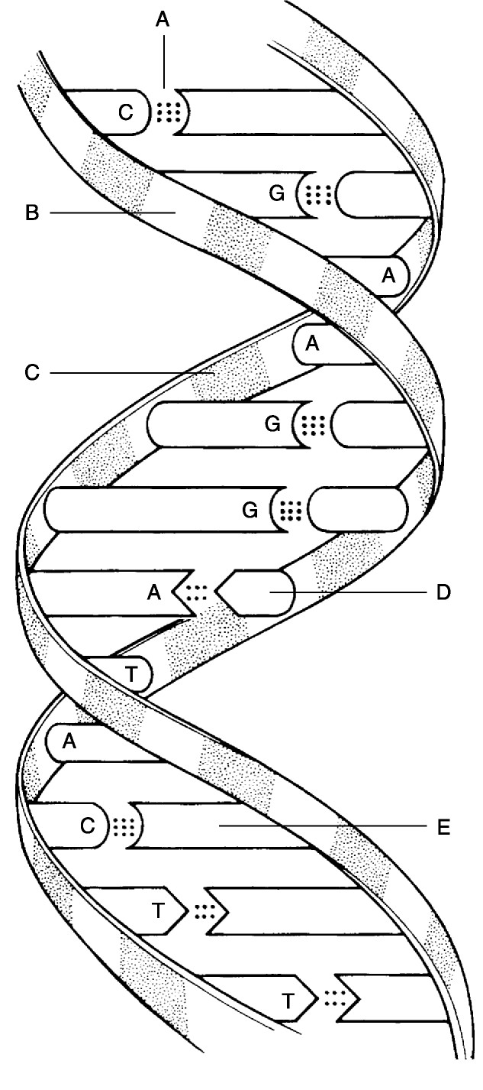

Be able to compare the nucleic acids, DNA and RNA.

DNA
Double-stranded
Deoxyribose sugar
Bases: Adenine: Thymine
Guanine: Cytosine

RNA
Single-stranded
Ribose sugar
Bases: Adenine: Uracil
Guanine: Cytosine
Review vocabulary

- Homeostasis
- Catalyst
- Disaccharide (i.e. sucrose, lactose, maltose)
- Denature (as it relates to enzymes)
- Monomer
- Polymer
- Polypeptide
- Triglyceride (3 fatty acids bonded to 1 glycerol)
- Fatty acids
- Emulsify (emulsifiers)
- Steroids
- Synthesis reaction
- Decomposition reaction
- Exchange reaction
- Exchange reaction
- Starch (stored polysaccharide in plants)
- Glycogen (stored polysaccharide in animals)
- Neutral
- Alkaline (basic/base)
- Acidic
- Polysaccharide
- Peptide bonds

Study to Know:

- Difference between synthesis and decomposition reactions.
- The role of carbohydrates (energy and surface antigens in cell to cell recognition)
- The four (4) elements that make up 96% of the human body.
- The function of lipids in the human body.
    - Nonpolar lipids can be broken down by EMULSIFIERS
    - Cushioning

- The role of hydrolysis in breaking disaccharides into monosaccharides.
- The function of proteins in the human body
    - (i.e. keratin forms part of hair and nails, hemoglobin transports oxygen in the blood; antibodies participate in immune response; actin aids muscle cell contraction)
- The characteristics of enzymes:
Biological catalysts.
Proteins
Lower activation energy
Denatured by heat; rendered non-functional
Usually ends in -ase (i.e. lactase breaks down lactose)

