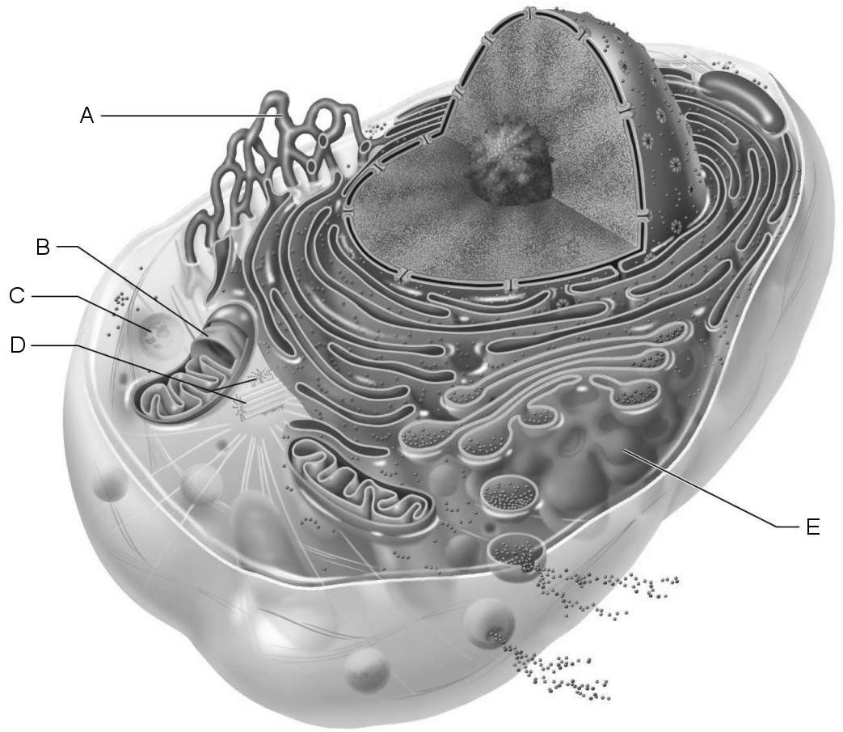

- Be able to identify name and function of each structure in the animal cell diagram above.

- Know the following terms and how they relate to the cell and its organelles: aerobic, ATP, enzyme, phagocytosis, exocytosis, mitotic spindle, lipid, steroid, cell division, synthesis, and autolysis.

- Know the structure and function of each of the following organelles: nucleus, mitochondria, lysosomes, ribosome, plasma (cell) membrane, rough endoplasmic reticulum, smooth endoplasmic reticulum, vesicle, nucleolus, flagella, cilia, microtubules, microfilaments, centrioles, flagella, cilia, microvilli and nuclear membrane (envelope).

- Distinguish between a cell inclusion and a cell organelle.

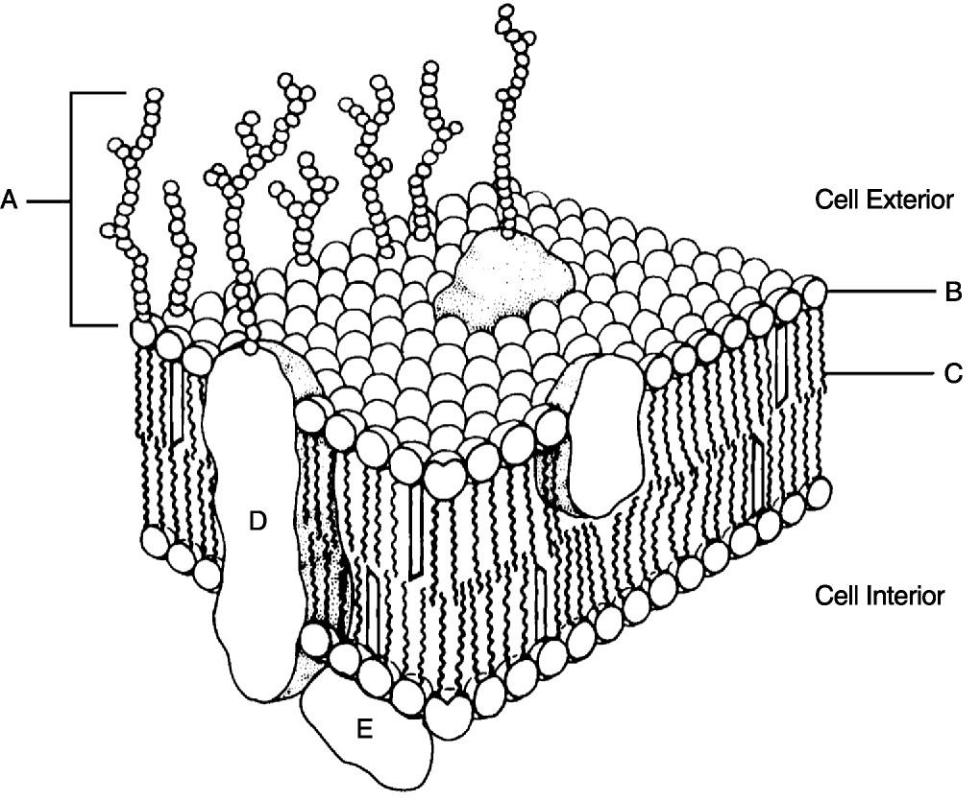
- Be able to identify name and function of each structure in the fluid mosaic model above.

- Know the following terms and how they relate to the membrane transport: hydrophilic heads, hydrophobic tails, glycocalyx, nonpolar regions, polar region, identification “tags”, peripheral proteins, and integral proteins.
- Distinguish between passive and active transport.

- Know the three (3) tenets of the cell theory.

- Be able to compare and contrast the structure and function of desmosomes, tight junctions, and gap junctions.

- What are the steps of protein synthesis?

- Where in the cell does each step of protein synthesis take place?

- What role does each of the following play in protein synthesis? Messenger RNA, ATP, ribosomal RNA, transfer RNA, and synthetase enzymes.

- Sketch and label the phase of the Cell Cycle and Mitosis.

- Be able to identify the description of interphase, prophase (late vs. early), metaphase, anaphase, and telophase.

- What happens to a human red blood cell placed in a hypotonic, isotonic, and hypertonic solutions?

