The Cardiovascular System Study Guide
Mrs. Bond-Jackson

Use PowerPoint slides

Study the following diagrams:

.
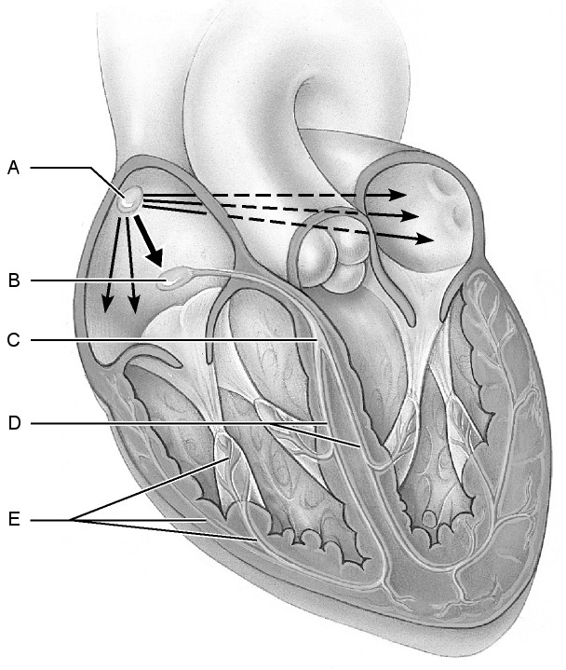

Diagram A
Know each part of the Intrinsic Conduction System.

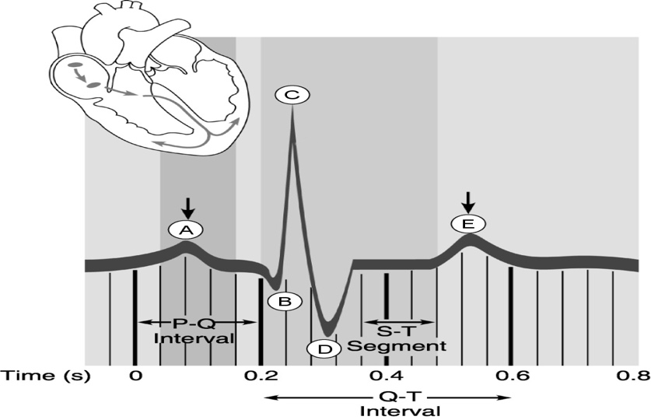
Diagram B
Know what each wave and interval represent. (PQRST)

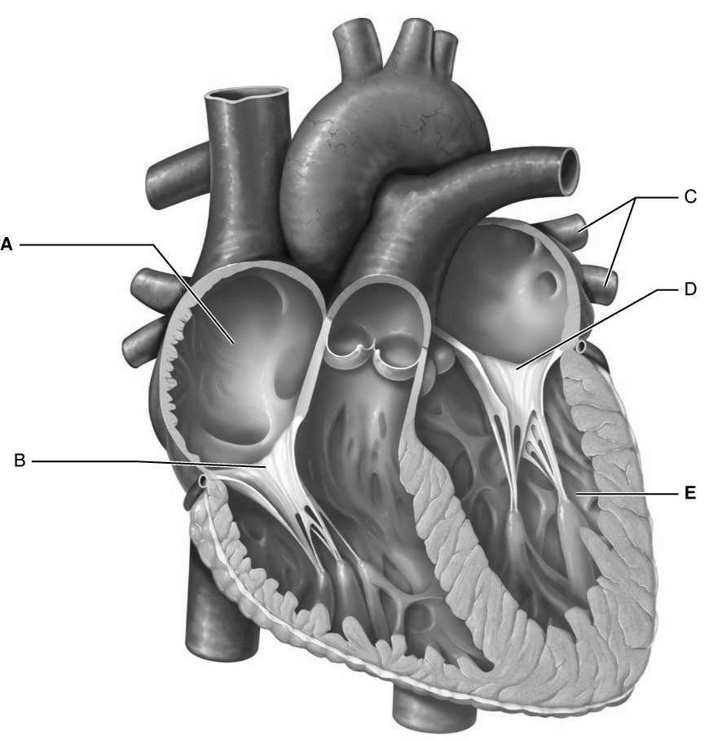

Diagram C
In addition to the lettered structures, know all parts of the diagram.

Study to know the function, structure and/or location of following:
- Valves (inside the heart)
Atrioventricular valves (AV), aka: mitral, bicuspid, tricuspid
Semilunar valves (aortic and pulmonary)

- Valves (outside the heart)
Veins (preventing backflow)

- Heart muscle
Myocardium
Epicardium
Endocardium
Pericardium (visceral v. parietal)

- Intrinsic Conduction System
AV node (pacemaker)
SA node
AV bundle (Bundle of HIS)
Purkinje fibers

- Arteries branching from the aorta
Brachiocephalic
Left common carotid
Left subclavian

- Pulse

- Location of arteries (pulse points)
Femoral
Temporal
Facial
Carotid
Brachial
Radial
Femoral
Popliteal
Posterior tibial
Dorsalis pedis

- Fenestrations (pores)
- Cause of heart sounds (lub and dub)

- Parts of the aorta
Ascending
Descending

- Coronary blood vessels
- Heart chambers (receiving and discharging)
- Vena Cava (superior and inferior)

- Blood pressure
Systolic v diastolic
Normal readings v hypertensive readings
Factors causing high and low blood pressure

- Starling’s Law
- Factors that increase/decrease heart rate
- Direction of blood flow through the heart, lungs and entire body beginning with right atrium.
- Structure and function of arteries vs. veins
- Organs supplied by carotid, hepatic and renal blood vessels
- Circle of Willis
- Location of strongest blood pressure
Arteries
Arterioles
Capillaries
Veins
Venules

- Location of oxygenated blood and deoxygenated blood (in heart).
- Number of pulmonary arteries
- Number of pulmonary veins
- Pulmonary arteries v. pulmonary veins (type of blood flowing through)
- Sympathetic Nervous System’s (fight or flight) effect on heart rate
- Parasympathetic Nervous System’s effect on heart rate.
- Heart formation (“tube heart”) vs complete heart in developing fetus (timeline)
- Factors affecting heart rate (increase and decrease)

